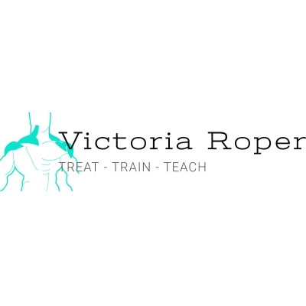
To be a successful Instructor or trainer, you must have a good understanding of human anatomy. Many students have no prior anatomy training so I designed an anatomy program to address this and prepare students for any future courses or workshops they wish to attend.

Functional Anatomy Level 1 (FA1) is a 20-hour course (will be shorter when completed individually or online) ideal for new students wanting to commence their anatomy study or fitness professionals wishing to refresh their knowledge. It's also great if you train and want to understand your own body on a whole new level.

This course will help you build a foundation in functional anatomy and physiology and gain confidence in understanding how the human body moves, both during exercise and functional activity (biomechanics). It will support future education by improving your own movement, workouts and understanding of the human body.

Over 20 hours you will:

- Learn to communicate and understand the language and terminology of anatomy – considering positions, directions, force vectors, planes of motion, joint actions and names.
- learn the major muscles of the body, origins and insertions and their function.
- Learn to recognize different postural types and begin to apply your knowledge of anatomy to basic exercises.

Recommended learner resource:
https://www.amazon.co.uk/Trail-Guide-Body-Locate-Muscules/dp/0982978650/ref=sr_1_1?ie=UTF8&qid=1538663475&sr=8-1&keywords=trail+guide+to+the+body

This will be the one and only anatomical reference book you will require through your fitness journey. It will be used extensively throughout the course and you will continue to reference it on your journey and career as a trainer or student.

